Experiment 9: Design of Convolutional Layer in Zynq SoC

Objectives of this Experiment
  - To design and simulate a 3×3 Convolutional Layer using RTL (Verilog HDL) for image processing and Convolutional Neural Network (CNN) accelerator applications.
  - To configure nine 8-bit signed input pixel registers (p0–p8) for the 3×3 input window, nine 8-bit signed kernel coefficient registers (k0–k8), and a 16-bit signed bias input.
  - To implement parallel multiply–accumulate hardware logic computing 9 simultaneous products, accumulating partial sums, and adding bias to produce a 20-bit signed output (y).
  - To construct a comprehensive Verilog testbench (tb_conv2d_3x3), simulate the design in Vivado Simulator (XSIM) across multiple filter test cases (All-ones, Edge detection, and Mixed signed values), and verify output accuracy against theoretical calculations.
Required tools:
Xilinx Vivado Design Suite, Vivado Simulator (XSIM), Verilog HDL, Windows / Linux Operating System.

Method
Step 1: Project Creation — Open Xilinx Vivado and create a new RTL project. Enter the project name and select the target FPGA device or board.
Step 2: Module Architecture & Ports Declaration — Create a Verilog module named conv2d_3x3 to implement a 3×3 convolution operation. Declare nine 8-bit signed input pixel ports (p0 to p8) representing the 3×3 image window, nine 8-bit signed kernel coefficient ports (k0 to k8), a 16-bit signed bias input (bias), and a 20-bit signed convolution output (y).
Step 3: MAC Logic Implementation — Implement parallel multiply–accumulate logic: compute 9 product terms (m0 = p0 * k0 through m8 = p8 * k8), accumulate the products (sum = m0 + m1 + ... + m8), and add the bias value (y = sum + bias).
Step 4: Testbench Program Writing — Create a testbench file (tb_conv2d_3x3) instantiating the conv2d_3x3 module. Write test cases for: (1) All-ones kernel (p_i = 10, k_i = 1, bias = 5), (2) Edge detection kernel (p4 = 20, p_others = 5, k4 = 8, k_others = -1, bias = 0), and (3) Mixed signed values (p and k containing negative integers, bias = 2).
Step 5: Simulation & Result Verification — Launch Vivado Simulator (XSIM) and execute behavioral simulation. Observe output waveforms for each test case, record the y values, and compare them against manual theoretical calculations.

Program

1. Verilog RTL Code: 3×3 Convolutional Layer
module conv2d_3x3 (
input signed [7:0] p0, p1, p2,
input signed [7:0] p3, p4, p5,
input signed [7:0] p6, p7, p8, // 3x3 input window
input signed [7:0] k0, k1, k2,
input signed [7:0] k3, k4, k5,
input signed [7:0] k6, k7, k8, // 3x3 kernel coefficients
input signed [15:0] bias, // 16-bit bias term
output signed [19:0] y // 20-bit convolution output
);
wire signed [15:0] m0, m1, m2, m3, m4, m5, m6, m7, m8;
wire signed [19:0] sum;
// Parallel 8-bit x 8-bit Multipliers
assign m0 = p0 * k0;
assign m1 = p1 * k1;
assign m2 = p2 * k2;
assign m3 = p3 * k3;
assign m4 = p4 * k4;
assign m5 = p5 * k5;
assign m6 = p6 * k6;
assign m7 = p7 * k7;
assign m8 = p8 * k8;
// Accumulation Tree and Bias Addition
assign sum = m0 + m1 + m2 + m3 + m4 + m5 + m6 + m7 + m8;
assign y = sum + bias;
endmodule

2. Verilog Testbench Code
`timescale 1ns / 1ps
module tb_conv2d_3x3;
// Inputs
reg signed [7:0] p0, p1, p2, p3, p4, p5, p6, p7, p8;
reg signed [7:0] k0, k1, k2, k3, k4, k5, k6, k7, k8;
reg signed [15:0] bias;
// Output
wire signed [19:0] y;
// Instantiate Device Under Test (DUT)
conv2d_3x3 uut (
.p0(p0), .p1(p1), .p2(p2),
.p3(p3), .p4(p4), .p5(p5),
.p6(p6), .p7(p7), .p8(p8),
.k0(k0), .k1(k1), .k2(k2),
.k3(k3), .k4(k4), .k5(k5),
.k6(k6), .k7(k7), .k8(k8),
.bias(bias),
.y(y)
);
initial begin // Test Case 1: All ones kernel
p0=8'd10; p1=8'd10; p2=8'd10;
p3=8'd10; p4=8'd10; p5=8'd10;
p6=8'd10; p7=8'd10; p8=8'd10;
k0=8'd1; k1=8'd1; k2=8'd1;
k3=8'd1; k4=8'd1; k5=8'd1;
k6=8'd1; k7=8'd1; k8=8'd1;
bias = 16'd5;
#10;
// Test Case 2: Edge detection-like kernel
p0=8'd5; p1=8'd5; p2=8'd5;
p3=8'd5; p4=8'd20; p5=8'd5;
p6=8'd5; p7=8'd5; p8=8'd5;
k0=-8'd1; k1=-8'd1; k2=-8'd1;
k3=-8'd1; k4= 8'd8; k5=-8'd1;
k6=-8'd1; k7=-8'd1; k8=-8'd1;
bias = 16'd0;
#10;
// Test Case 3: Mixed signed values
p0=8'd10; p1=-8'd5; p2=8'd3;
p3=8'd2; p4=8'd1; p5=-8'd4;
p6=8'd6; p7=8'd7; p8=8'd8;
k0=8'd1; k1=8'd2; k2=8'd1;
k3=8'd0; k4=8'd1; k5=8'd0;
k6=8'd1; k7=8'd2; k8=8'd1;
bias = 16'd2;
#10;
$stop;
end
endmodule
1. 2D Convolution Formula:
y = ( ∑ (p_i × k_i) for i = 0 to 8 ) + bias
2. Individual Test Case Arithmetic Verification:
• Test Case 1 (All ones kernel):
m0 = m1 = ... = m8 = 10 × 1 = 10
sum = 10 × 9 = 90
y = 90 + 5 = 95
• Test Case 2 (Edge detection-like kernel):
m4 = 20 × 8 = 160
m0 = m1 = m2 = m3 = m5 = m6 = m7 = m8 = 5 × (-1) = -5
sum = 160 + (8 × -5) = 160 - 40 = 120
y = 120 + 0 = 120
• Test Case 3 (Mixed signed values):
m0=10*1=10, m1=-5*2=-10, m2=3*1=3, m3=2*0=0, m4=1*1=1, m5=-4*0=0, m6=6*1=6, m7=7*2=14, m8=8*1=8
sum = 10 - 10 + 3 + 0 + 1 + 0 + 6 + 14 + 8 = 33
y = 33 + 2 = 35
3. Bit-Width Precision & Growth Analysis:
• Product Bit Width: 8-bit signed × 8-bit signed = 16-bit signed product (m0 to m8).
• Accumulator Growth: Summation of 9 16-bit signed terms requires ⌈log2(9)⌉ = 4 additional guard bits, yielding a 20-bit accumulator (sum).
• Final Output Bit Width: 20-bit sum + 16-bit bias = 20-bit signed output (y) without arithmetic overflow.
Observation table
Item | Test Scenario / Parameter | Expected Theoretical Output | Simulated Hardware Output | % Deviation / Status
1 | Test Case 1 (All-Ones Kernel) | y = (9 * 10 * 1) + 5 = 95 | y = 95 | 0% Error
2 | Test Case 2 (Edge Detection Kernel) | y = (20 * 8) + (8 * 5 * -1) + 0 = 120 | y = 120 | 0% Error
3 | Test Case 3 (Mixed Signed Inputs) | y = 33 + 2 = 35 | y = 35 | 0% Error
4 | Computational Accuracy | 100% MAC Precision | 100% MAC Precision | Verified

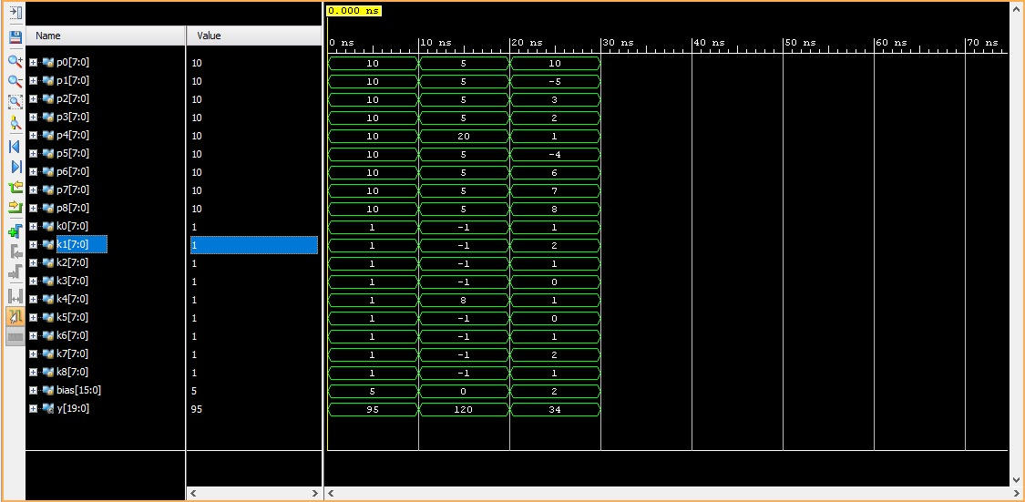
Figure: Output obtained for convolution process

Conclusion
The 3×3 Convolutional Layer RTL module was successfully designed, implemented, and simulated using Verilog HDL in Xilinx Vivado. The hardware architecture correctly executed 9 parallel 8-bit multiplications, accumulated the results, and added the 16-bit bias term to produce a 20-bit convolution output. The simulation results across all three test cases (All-ones, Edge detection, and Mixed signed values) matched theoretical calculations with 0% error, confirming the correct operational functionality of the convolutional layer hardware for AI workloads.

